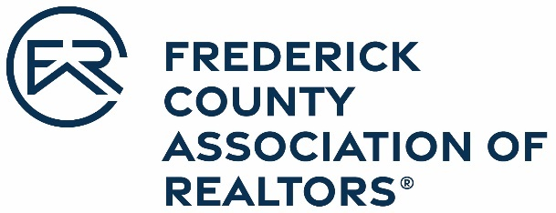

OFFICIAL ENTRY FORM
Frederick County Association of REALTORS®
2022 Community Service Award
Realtor or Affiliate

Nominations are due March 31, 2023

This award honors individual REALTOR® members who give unselfishly of their time to assist the Frederick County communities in which they live.

Nominee Name: _____________________________________________________________
Office: _____________________________________________________________________
Address: ___________________________________________________________________
___________________________________________________________________

Please attach a brief narrative that explains the nominee’s accomplishments in each of the following five categories:

- Local Association Activity – Association office and committee work, special assignments, seminar activity, education work, membership, and offices in local chapters of institute, societies, etc.
- State/National Association Activity – Service on state/national committees; special assignments; attendance at state/national associated functions and conventions (include the number of years of service.)
- Business Education Designations – Outstanding business accomplishments; seminar activity and education course work; designations held and/or candidate for designations; acquired job knowledge/professional education through various real estate and related courses, institutes, and seminars
- Civic Activity – Local, state, and national level participation in civic and service clubs, charitable activities, political action, fraternal or religious groups, etc. Include work that exhibits extraordinary and self-sacrificing acts of public service to the community.

Nominated by: _____________________________________________________________
Office Manager/Broker: _____________________________________________________________
Office Name: _____________________________________________________________
Nominee Signature: _____________________________________________________________

