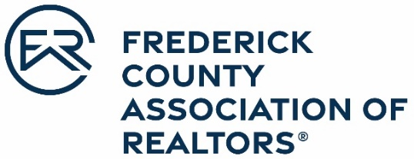

OFFICIAL ENTRY FORM
Frederick County Association of REALTORS®
2022 Janet McKinney Award
Excellence in Education and Learning

Nomination are due March 31, 2023

Awarded to a member that demonstrates a passion for learning and the need for continued self-improvement. Learning is integrated with work and knowledge is gained to improve their business results.

The award should consider the following attributes:
- A recognition of the learning process for its own sake.
- Works under the assumption that everything is subject to re-examination and acts on opportunities to implement positive change
- Converts information into opportunity
- Views education as the stepping stone to further growth.
- Recognizes and responds to different learning preferences.
- Cultivates others abilities and talents
- Has an open attitude of self-evaluation and improvement.
- Promotes education and encourages others to improve themselves through education.

Nominee Name: _
Office: _
Address:

Please choose the attributes from above and in detail explain why you are nominating this individual for this distinguished award.
Nominated by: ______

Office Manager/Broker: _______
Office Name: _______
Nominee Signature: _

Frederick County Association of REALTORS® 478 Prospect Blvd.
Frederick, MD 21701 www.fcar.org | info@fcar.org | 301-663-0757

