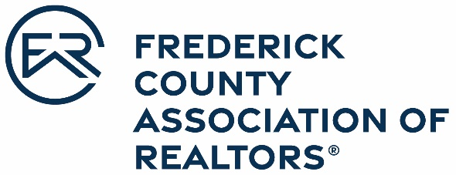

OFFICIAL ENTRY FORM
Frederick County Association of REALTORS®
2022 Community Activist Award

Nominations are due March 31, 2023

This award honors individual REALTOR® members who give unselfishly of their time and make a notable contribution to the Frederick County Community.

Nominee Name: _____________________________________________________________
Office: _____________________________________________________________________
Address: ___________________________________________________________________
___________________________________________________________________

Please attach a brief narrative that explains the nominee’s accomplishments in each of the following five categories:

- Local, state, and national level participation in civic and service clubs, charitable activities, political action, fraternal or religious groups, etc. Include work that exhibits extraordinary and self-sacrificing acts of public service to the community.
- Minimum length of time in the profession as a Realtor® is five years
- Work that exceeds the strategic goal of enhancing FCAR’s image in the community.
- Work that exemplifies the character and ethics of a Realtor®.
- Work that has been recognized by industry peers.

Nominated by: _____________________________________________________________
Office Manager/Broker: _____________________________________________________________
Office Name: _____________________________________________________________
Nominee Signature: _____________________________________________________________

